Project ΔΟΜΕΣ ΔΕΔΟΜΕΝΩΝ
ΟΝΟΜΑ: ΣΑΒΒΑΣ
ΕΠΙΘΕΤΟ: ΣΥΜΕΩΝΙΔΗΣ
ΑΕΜ: 4268
ΤΜΗΜΑ: Ε3 ΔΕΥΤΕΡΑ 12-14

mainMyProject.cpp
#include "Pinakas.h"
#include "RandMT.h"
#include <iostream>
#include <ctime>
#include <fstream>
#include <cstdlib>

using namespace std;

int main(int argc, char** argv)
{
Pinakas a,b;
int type,n;
clock_t ct0,ct1;
double sec1,sec2,sec3,sec4;

ofstream fout;

fout.open("TIME.txt");

cout << "Student" << endl;
cout << "=======" << endl;
cout << "Name: Symeonidis Savvas" << endl;
cout << "AEM: 4268" << endl;
cout << endl;
cout << "Computer characteristics" << endl;
cout << "========================" << endl;
cout << "CPU: Intel(R)" << endl;
cout << " Core(TM)i7-75000U 2.70GHz 2.90GHz" << endl;
cout << "RAM: 8.00GB" << endl;
cout << endl;

cout << "Array Size? ";
cin >> n;

a.setArraySize(n);
a.createArray();

b.setArraySize(n);
b.createArray();

cout << endl;
cout << "Array types: " << endl;
cout << " 1. Random 100% " << endl ;
cout << " 2. Sorted 50%, Random 50%" << endl ;
cout << " 3. Sorted ASC" << endl ;
cout << " 4. Sorted DESC" << endl ;
cout << endl;

cout << "Choose array type: " ;
cin >> type;
cout << endl;

switch(type)
{
case(1):
a.fillArray();
break;

case(2):
a.fillArraySR();
break;

case(3):
a.fillArrayASC();
break;

case(4):
a.fillArrayDESC();
break;

default:

cout << "End" << endl;
}

cout << "Sorting --> ";

if(type<=4)
{
a.copyArray(b);
//b.printArray();
ct0 = clock();
cout << "Bubble...";
b.bubbleSort();
ct1 = clock();
sec1 = double (ct1-ct0)/CLOCKS_PER_SEC;
fout << "BUBBLE SORT\n"
<< "Xronos: "
<< sec1 << endl;

a.copyArray(b);
//b.printArray();
ct0 = clock();
cout << "Select...";
b.selectSort();
ct1 = clock();
sec2 = double (ct1-ct0)/CLOCKS_PER_SEC;
fout << "===========\n"
<< "SELECT SORT\n"
<< "Xronos: "
<< sec2 << endl;

a.copyArray(b);
//b.printArray();
ct0 = clock();
cout << "Insert...";
b.insertSort();
ct1 = clock();
sec3 = double (ct1-ct0)/CLOCKS_PER_SEC;
fout << "===========\n"
<< "INSERT SORT\n"
<< "Xronos: "
<< sec3 << endl;

a.copyArray(b);
//b.printArray();
ct0 = clock();
cout << "Quick...";
b.quickSort(0,n-1);
ct1 = clock();
sec4 = double (ct1-ct0)/CLOCKS_PER_SEC;
fout << "===========\n"
<< "QUICK SORT\n"
<< "Xronos: "
<< sec4 << endl;
}
cout << "FINISHED!" << endl;

a.freeArrayMem();
fout.close();
return 0;
}

Pinakas.h
#ifndef PINAKAS_H
#define PINAKAS_H

class Pinakas
{
private:
unsigned int *p;
unsigned int n;
public:
void setArraySize(unsigned int n1);
void createArray();
void fillArray(); //100% random
void fillArraySR(); //50% sorted, 50 % random
void fillArrayASC(); //Sorted ASC (áõîïõóá)
void fillArrayDESC(); //Sorted DESC (öèéíïõóá)
void printArray();
void freeArrayMem();
void copyArray(Pinakas ant);
void bubbleSort();
void selectSort();
void insertSort();
void quickSort(int left, int right);
};

#endif

Pinakas.cpp
#include "Pinakas.h"
#include "RandMT.h"
#include <iostream>
#include <cstdlib>
#include <ctime>
#include <fstream>

using namespace std;

void Pinakas::setArraySize(unsigned int n1)
{
n = n1;
}

void Pinakas::createArray()
{
p = new unsigned int[n];
}

void Pinakas::fillArray() //100% random
{
RandMT myRandom;
int i;
RandMT(time(NULL));

for(i=0; i<n; i++)
{
p[i] = myRandom();
}
}

void Pinakas::fillArraySR() //50% sorted, 50 % random
{
RandMT myRandom;
int j,i,mid;
mid=(n-1)/2;
RandMT(time(NULL));
for(i=0;i<=mid;i++)
{
p[i]=i*10;
}
for(j=mid+1;j<n;j++)
{
p[j]=myRandom();
}
}

void Pinakas::fillArrayASC() //Sorted ASC (áõîïõóá)
{
int i;
for(i=0;i<n;i++)
{
p[i]=i*10;
}
}

void Pinakas::fillArrayDESC() //Sorted DESC (öèéíïõóá)
{
int j,i,temp;

for(i=0;i<n;i++)
{
p[i]=i*10;
}
j=i-1;
i=0;
while(i<j)
{
temp = p[i];
p[i] = p[j];
p[j] = temp;
i++;
j--;
}
}

void Pinakas::printArray()
{
int i;
for(i=0; i<n; i++)

cout << p[i] << " ";

cout << endl;
}

void Pinakas::freeArrayMem()
{
delete []p;
}

void Pinakas::copyArray(Pinakas ant)
{
int i;
for(i=0; i<n; i++)
ant.p[i] = p[i];
}

void Pinakas::bubbleSort()
{
int temp,i,j;
for(i=1; i<n; i++)
{
for(j=n-1; j>=i; j--)
if(p[j-1] > p[j])
{
temp = p[j-1];
p[j-1] = p[j];
p[j] = temp;
}
}
}

void Pinakas::selectSort()
{
int i,k,j,min;
for(i=0;i<n-1;i++)
{
k=i;
min=p[i];
for(j=i+1;j<n;j++)
{
if(p[j]<min)
{
k=j;
min=p[j];
}
}
p[k]=p[i];
p[i]=min;
}
}

void Pinakas::insertSort()
{
int i,j,x;

for(i=1; i<n; i++)
{
x = p[i];
j = i-1;
while( j>=0 &&
p[j]>x)
{
p[j+1] = p[j];
j = j-1;
}
p[j+1] = x;
}
}

void Pinakas::quickSort(int left, int right)
{
int i, j, mid, x;

if(left < right)
{
i = left;
j = right;
mid = (left+right)/2;
x = p[mid];
while(i < j)
{
while(p[i] < x)
i++;
while(p[j] > x)
j--;
if(i < j)
{
if(p[i] == p[j])
{
if(i < mid)
i++;
if(j > mid)
j--;
}
else
{
swap(p[i],p[j]);
}
}
}
quickSort(left,j-1);
quickSort(j+1,right);
}
}

100000

1η εκτέλεση
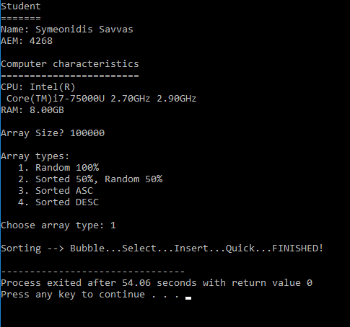

ARRAY SIZE = 100000, ARRAY TYPE = Random 100%

EXECUTION TIMES (seconds) = 54.06

BubbleSort SelectSort InsertSort QuickSort
========= ======== ======== ========
31.05 10.048 6.048 0.015

2η εκτέλεση
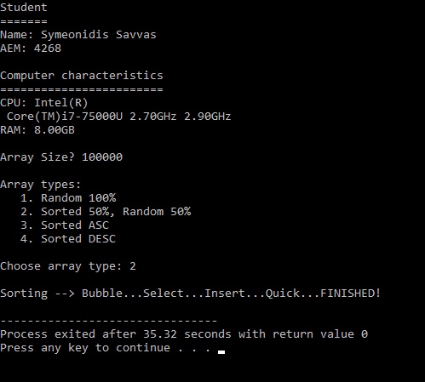

ARRAY SIZE = 100000, ARRAY TYPE = Random 100%

EXECUTION TIMES (seconds) = 35.32

BubbleSort SelectSort InsertSort QuickSort
========= ======== ======== ========
16.674 10.032 1.516 0

3η εκτέλεση
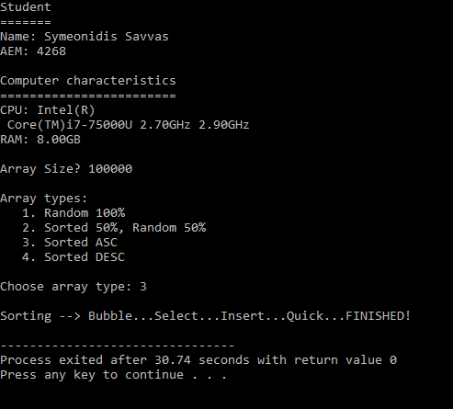

ARRAY SIZE = 100000, ARRAY TYPE = Random 100%

EXECUTION TIMES (seconds) = 30.74

BubbleSort SelectSort InsertSort QuickSort
========= ======== ======== ========
12.079 10.033 0 0

4η εκτέλεση
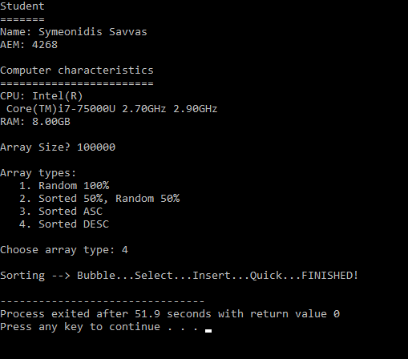

ARRAY SIZE = 100000, ARRAY TYPE = Random 100%

EXECUTION TIMES (seconds) = 51.9

BubbleSort SelectSort InsertSort QuickSort
========= ======== ======== ========
22.236 11.267 12.079 0.016

200000

1η εκτέλεση
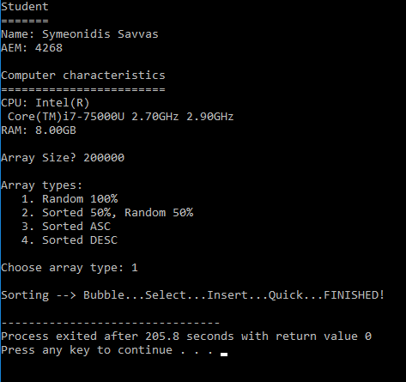

ARRAY SIZE = 200000, ARRAY TYPE = Random 100%

EXECUTION TIMES (seconds) = 205.8

BubbleSort SelectSort InsertSort QuickSort
========= ======== ======== ========
125.435 40.451 24.408 0.032

2η εκτέλεση
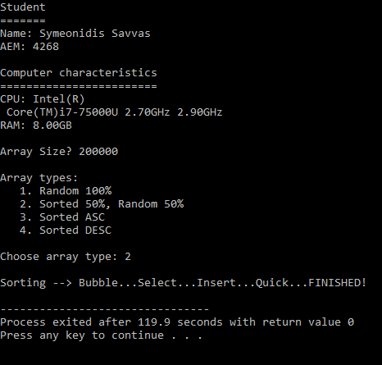

ARRAY SIZE = 200000, ARRAY TYPE = Random 50% & Sorted 50%

EXECUTION TIMES (seconds) = 119.9

BubbleSort SelectSort InsertSort QuickSort
========= ======== ======== ========
67.152 40.648 6.327 0.022

3η εκτέλεση
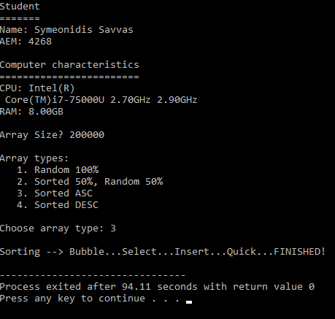

ARRAY SIZE = 200000, ARRAY TYPE = Sorted ASC

EXECUTION TIMES (seconds) = 94.11

BubbleSort SelectSort InsertSort QuickSort
========= ======== ======== ========
48.179 40.237 0.001 0.006

4η εκτέλεση
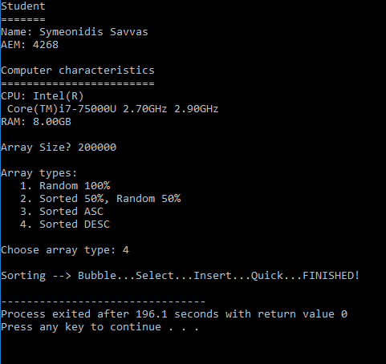

ARRAY SIZE = 200000, ARRAY TYPE = Sorted DESC

EXECUTION TIMES (seconds) = 196.1

BubbleSort SelectSort InsertSort QuickSort
========= ======== ======== ========
89.441 45.233 48.566 0.007

100000
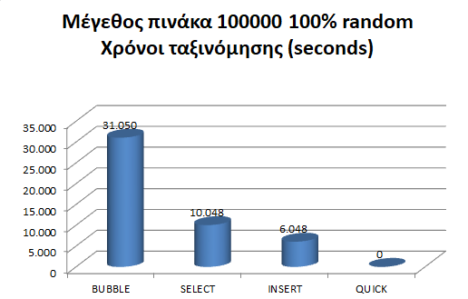
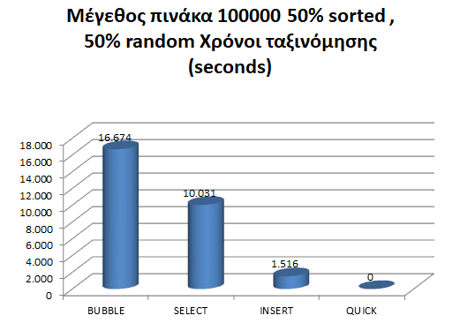
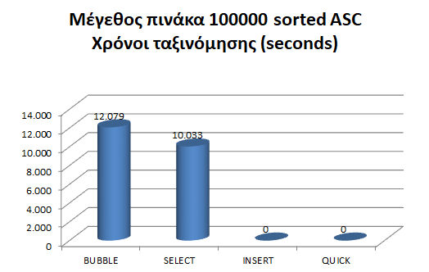
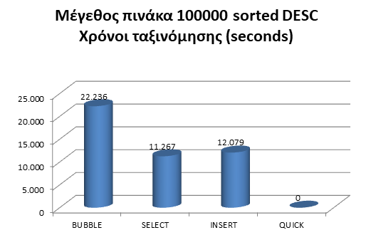
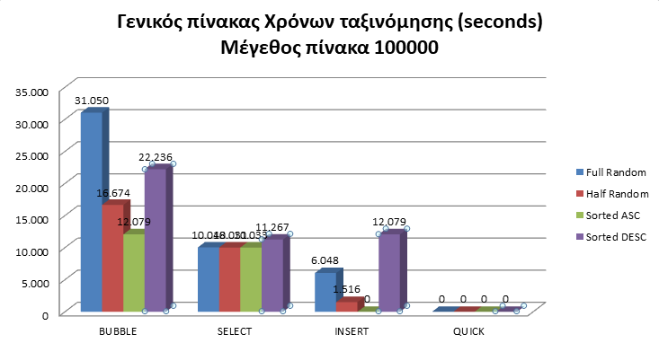

200000

